**Report**

|  |  |
| --- | --- |
| Date | 05 October 2025 |
| Team ID | SWUID20250215169 |
| Project Name | Global Food Production Trends and Analysis: A Comprehensive Study from 1961 to 2023 Using Power BI |
| Maximum Marks | 5 Marks |

A report is a comprehensive document that provides a detailed and structured account of data analysis, findings, and insights. It is typically used for in-depth analysis, documentation, and communication of results. Reports are suitable for a diverse audience, including decision-makers, analysts, and stakeholders who need a comprehensive understanding of the data.

Designing a report in Power BI involves connecting to data sources, creating visualizations like charts and graphs, customizing their appearance and interactivity, organizing them logically on the canvas, formatting elements for consistency and clarity, and optionally creating dashboards for a summarized view. Throughout the process, it's essential to consider the audience's needs and ensure the report effectively communicates insights from the data. Finally, iterate based on feedback to continually improve the report's design and usefulness.

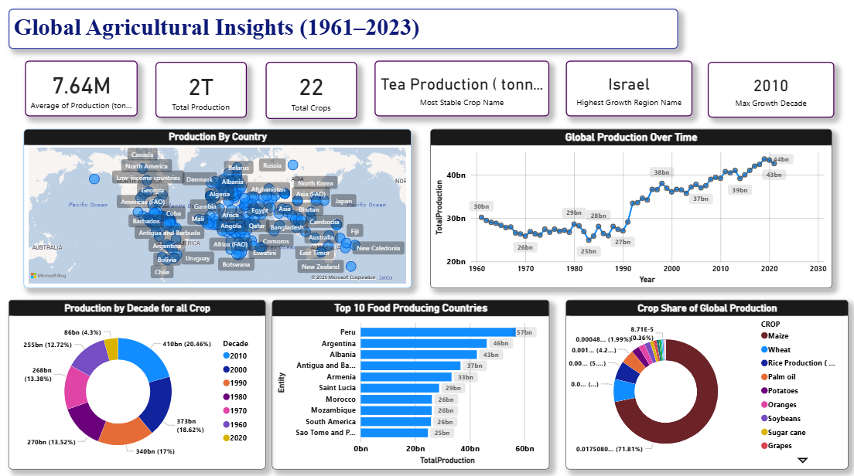

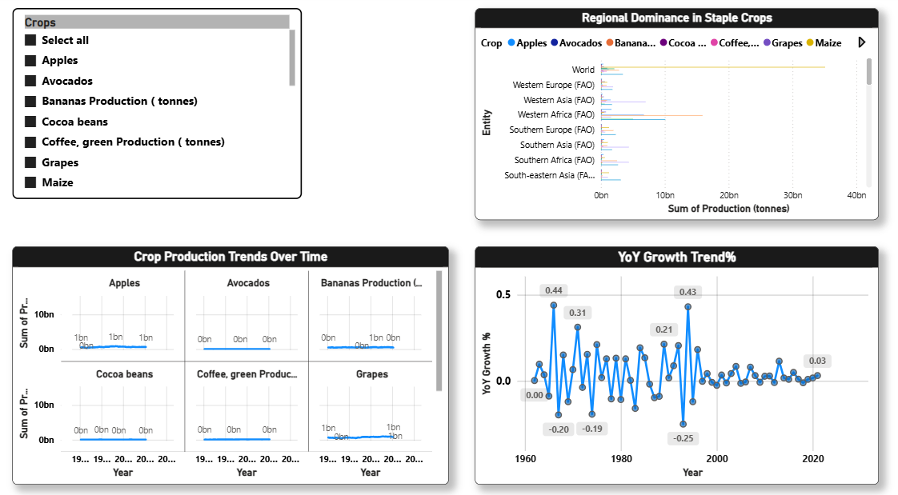

Observations drawn from reports in Power BI can provide valuable insights into business performance and trends.

Highlights:

1. Total Production – 2 Trillion Tonnes . Confirms the magnitude of global agricultural output, reflecting unprecedented productivity since the 1960s.
2. Top Crop – Sugar Cane. Continues to dominate global production across regions, reaffirming its significance in both food and industrial use.
3. Average Production – 8.86 Billion Tonnes. Indicates a globally sustained output pattern over the decades, showcasing resilience in agricultural systems.
4. YoY Growth % – (-0.02%). Suggests that 2% decrease in Production Compared to the previous year, aligning with global sustainability and land-use constraints.

**Insights from Visuals**

1. Global Map Visualization —
   * Asia and South America are the largest food producers.
   * Africa demonstrates potential growth zones, especially in fruits and coffee crops.
   * Developed nations maintain moderate production but higher efficiency per hectare.
2. Total Production Over Time —
   * Strong upward trend till 2010, then stabilization.
   * Indicates agricultural modernization and climate adaptation shaping global output.
3. Top Crops by Total Production —
   * Sugar Cane (1.2T tonnes), Wheat (282B tonnes), and Rice (269B tonnes) dominate.
   * Fruit crops like Bananas, Oranges, and Grapes contribute to diversification.
4. Decade-Wise Production —
   * 2010s stand as the highest-producing decade (~410B tonnes).
   * Growth across decades clearly reflects technological improvements and global collaboration in agriculture.
5. Top 10 Producing Countries —
   * China, India, and the USA lead global output.
   * Brazil and Indonesia show strong positions due to sugarcane and fruit exports.
   * Emerging producers like Uzbekistan and Nigeria show rapid growth trajectories.
6. YoY Growth Trend —
   * Highlights fluctuations corresponding to economic and environmental cycles.
   * Declining volatility after 2000 shows a mature and efficient food production system.

7. Crop Production Comparison Over Years —

* Shows single production over all years and have a feature of comparing multiple crops with each other.

8. Regional Dominance in Crops —

* Shows particular Crop Production in each Region to demonstrate which region is producing more comparative to other regions.